Education Week (edweek.org)

What Happened When Students Led Fights to Reverse Book Bans
By Eesha Pendharkar — July 18, 2023 7 min read
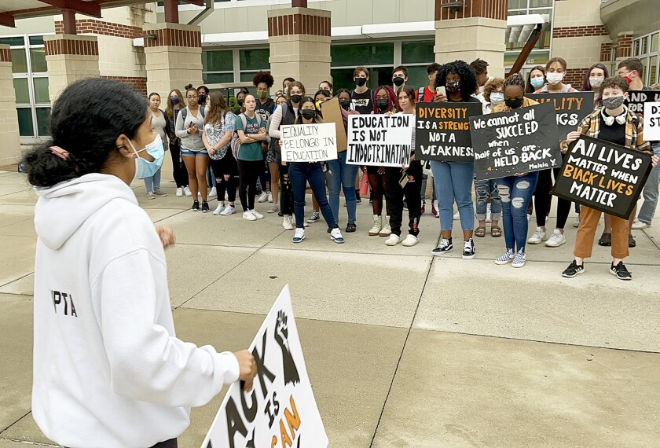
Edha Gupta at a protest at Central York School District, where students, teachers and community members gathered to fight against a ban on 300 books and educational resources.
Edha Gupta had attended Central York High School for her entire school career, and she never saw herself as an Indian-American girl reflected in the books she was assigned to read. Then, in September 2021, she read in the local newspaper that her district, located about two hours west of Philadelphia, had barred teachers from using about 300 books, articles, and documentaries related to diversity, equity, and inclusion that a district diversity committee had compiled in response to the racial justice activism that followed George Floyd’s 2020 murder by Minneapolis police.
That was the final straw for Gupta, who decided she had to speak up against what she perceived as an attempt to ban books that finally would represent students like her. So she worked with her peers in the Panther Anti-Racist Union—a group of teachers and students that supports student activism and is named for the school mascot—to develop a strategy to protest the bans, which mostly prohibited the classroom use of books and articles about racism and works by authors of color.
The Friday after news of the ban broke, Gupta asked students to wear black to school to demonstrate their dissent. The following Monday, 15 minutes before the start of classes, students started gathering outside school buildings with signs that read “education is not indoctrination” and “diversity is a strength not a weakness,” she said.
After a couple weeks of protests and the resulting national media attention, the Central York district agreed to reverse the ban and allow teachers to use the materials in classes.
“It is just disheartening to know how much was required to put into that to make that happen, but at the same time, I’m so happy that we were able to make this tangible change,” said Gupta, who’s now 19 but was a high school senior when the protests took place.
The protests in Central York are among at least a dozen examples nationwide of students organizing to resist books bans in recent years as the restrictions on works housed in school libraries and classrooms have spread across the country. The student resistance is a small, but growing trend as districts continue to limit students’ access to books and other materials that have drawn parent and community objections, said Sabrina Baêta, a program consultant with the Freedom to Read campaign at PEN America.
Where students have put up an organized resistance, they’ve injected momentum into efforts to oppose book bans, said Baêta, whose estimate that at least a dozen student groups have organized to resist book bans comes from a review of local news coverage.
“Sometimes they’re successful in either restarting the process of reconsidering a book or getting some books back into availability, and sometimes not,” she said. “But regardless, I found the public and the community really listens when a student speaks out.”
A year after Gupta and her classmates started protesting book bans in Central York, Millie Bennett walked into her AP Literature classroom in Beaufort County, S.C., to an announcement that the district was pulling 97 books from school libraries for review after parents and community members objected to the titles in board meetings, calling them sexually explicit or inappropriate.
Along with other members of the student organization she was the president of, called the Diversity Awareness Youth Literacy Organization, or DAYLO, Bennett started attending every school board meeting she could to oppose the bans.
As a queer woman, Bennett said she felt the district was taking away books that represented people like her.
“I really wish this wasn’t something that [fell] to the students,” Bennett said. “But as I see it, the students are the most impactful voice in this, and they are the ones being directly impacted. So they have the most important things to say.”

Central York reversed course on 300 books, but smaller-scale bans have persisted
The Central York district’s November 2020 decision to prohibit teachers’ use of works from the list of 300 books and other educational materials compiled by teachers, students, and parents on the diversity committee made the district one of the first in the country to initiate a mass book ban.
However, the initial decision went largely unnoticed until the high school principal shared the list in an email with teachers in 2021, asking them to refrain from using any resource from it in their classrooms. Local media then wrote about the list, which is how Gupta and other students found out.
Some of the banned titles included well-known works about those involved in the civil rights movement and the fight for LGBTQ+ rights, including I am Rosa Parks by Brad Meltzer, The Story of Ruby Bridges by Robert Coles, and Pride: The Story of Harvey Milk & the Rainbow Flag by Rob Sanders. (The banned list of resources also included an EdWeek opinion essay from June 2020 by UCLA professor Tyrone Howard entitled “How to Root Out Anti-Black Racism From Your School.”)
As the students’ protests gained local media attention and drew support from teachers, parents, and community members, the building public opposition eventually led the school board to reverse the ban, said Ben Hodge, a Central York performing arts teacher and co-adviser to the Panther Anti-Racist Union.
The district did not respond to multiple requests for comment from administrators and board members.
In a September 2021 statement, Jane Johnson, then president of the Central York school board, explained that parents in the district had raised objections to the list of diversity committee resources.
“What we are attempting to do is balance legitimate academic freedom with what could be literature/materials that are too activist in nature, and may lean more toward indoctrination rather than age-appropriate academic content,” Johnson’s statement read.
Patricia Jackson, an English teacher and co-adviser to the Panther group, said the district’s prohibition on use of the resources “had a chilling effect on all the teachers because if there was a book on the list, teachers started removing them from their classroom libraries. And you had some librarians who were afraid for their jobs, who also started removing the books from the school libraries.”
While the district ultimately reversed course on the initial ban, it banned two more titles from libraries earlier this year—Push by Sapphire and A Court of Mist and Fury by Sarah J. Maas. Push is the story of a Black girl as she experiences abuse and neglect, while A Court of Mist and Fury is the second book in a four-part fantasy series. Both books include descriptions of sex or sexual abuse.
Although Gupta has graduated, students from the Panther Anti-Racist Union continue to oppose the bans at board meetings, Hodge said.

Many of the 97 challenged books are still withheld from library shelves in Beaufort County
In Beaufort County, Bennett and classmates started attending board meetings every other week to complain about the book bans, and also went to the South Carolina state house to talk to lawmakers about the bans and legislation, Bennett said.
A documentary film crew took an interest in DAYLO, and arranged for the students to meet with U.S. Rep. Jamie Raskin, D-Md., in Washington, and with Illinois’ secretary of state in Chicago, Bennett said.
“It was really important for us to be able to take that opportunity and really run with it because we’re not the only county or state that has been facing these book bans,” she said. “But we’re really a success story on how many we’ve been able to get back on the shelves, and how much our community has come out to support us.”
So far, the district has returned 10 of the challenged books to school libraries following a full review, permanently removed three, and limited access to 30 titles to high school students only. Reviews are still pending for 45 books, according to a list provided by the district.
But at a school board meeting on Jan. 17, while discussing which library books to put back on shelves, two board members, William Smith and Chloe Gordon, commended the students for speaking up.
At that meeting, a majority of board members voted to return seven books to library shelves, following a review committee’s recommendation.
“I more so want to thank those students for staying here and coming here to this meeting, and let them know that your voices are heard,” Smith said. “You are the driving force behind my vote tonight. So I thank you for being here and standing up for what you believe.”
Link to Article: https://www.edweek.org/teaching-learning/what-happened-when-students-led-fights-to-reverse-book-bans/2023/07

